A

**Audit Course Report On**

“Leadership and Personality Development”

Submitted to

**Savitribai Phule Pune University, Pune**

**In Partial Fulfillment of**

**T.E. Computer Engineering**

**T.E. Semester II**

Submitted by

**Mr. Adityaraj Sunil Patil Under the Guidance of**

**Mrs. Rutika Shah**



**Department of Computer Engineering**

**KJEI’S**

**Trinity College of Engineering and Research, Pune-48**

**Academic Year 2024-25**

KJ’s EDUCATIONAL INSTITUTES

**TRINITY COLLEGE OF ENGINEERING AND RESEARCH,PUNE**

( **Accredited by NAAC with A+ Grade** Approved by AICTE & Affiliated to SPPU,Pune**)**

Sr. No.25 & 27, Near Khadi Machine Chowk, Kondhawa Annexe, Pune-48, Maharashtra

**Department of Computer Engineering CERTIFICATE**

This is to certify that the Audit Course report entitled **“Leadership and Personality Development”** being submitted by **Mr. Adityaraj Sunil Patil** is a Bonafide work carried out by him under the supervision and guidance of **Prof. Rutika Shah** in fulfilment of the requirement for **TE Computer Engineering** course of Savitribai Phule Pune University, Pune in the academic year 2024-25.

Prof: Rutika Shah Dr. Geetika Narang

**Class Teacher HOD Computer Engineering TCOER, Pune**

**Date: 11-04-2025**

**Place: Pune**

# ABSTRACT

Leadership and personality development are two interrelated pillars that play a crucial role in shaping an individual's journey towards success, especially in today’s fast-paced, ever-evolving world. While leadership pertains to the capability to influence, motivate, and direct people towards a shared objective, personality development focuses on enhancing one's personal qualities, behaviours, and mindset to grow both individually and professionally.

A good leader is not merely someone who holds a position of authority, but someone who understands themselves, communicates effectively, manages emotions wisely, and remains composed under pressure. These qualities fall under the umbrella of emotional intelligence and self-awareness—both of which are essential in managing teams, resolving conflicts, and making strategic decisions. Leadership also requires adaptability and the courage to face uncertainties, especially in complex and unpredictable situations.

On the other hand, personality development is a continuous process of refining traits such as positivity, resilience, adaptability, and openness to learning. These traits are vital for navigating life’s challenges, handling criticism, and embracing change. Individuals who work on personality development tend to have higher levels of self-confidence, emotional stability, and mental strength. They are better equipped to deal with failures, maintain productive relationships, and persevere through difficulties.

Together, leadership and personality development enhance an individual's ability to contribute meaningfully to society and the workplace. A person who develops these qualities becomes not only an effective leader but also an inspiring team player, a confident communicator, and a role model for others. These attributes ultimately lead to greater achievements, both in personal endeavours and professional milestones.

In essence, the cultivation of leadership skills along with the continuous growth of one's personality ensures holistic development. It empowers individuals to make impactful decisions, lead with empathy, build lasting connections, and pursue excellence with determination and grace.

# INTRODUCTION

Leadership development is a comprehensive process that involves the identification, nurturing, and guidance of individuals with the potential to become future leaders. In many progressive organizations, this responsibility is often undertaken by the Human Resources department in collaboration with senior management. Their goal is to recognize high-potential employees often referred to as “fast-trackers” and provide them with the resources and support necessary to evolve into effective leaders.

This development process is not limited to theoretical learning but is enriched through practical exposure and mentoring. Companies invest in leadership by enrolling selected candidates in specialized training programs, leadership workshops, seminars, and retreats. These engagements are designed not only to enhance skills but also to provide a platform where emerging leaders can reflect, interact, and grow. Such initiatives represent an organizational commitment to long-term leadership building.

Leadership development is inherently a two-way relationship that thrives on mutual interest. The organization must be committed to investing time and resources into grooming its future leaders, while the candidates themselves must be driven, enthusiastic, and willing to learn. When this synergy is achieved, the result is meaningful organizational growth and sustainable leadership.

Notable organizations such as Infosys, Sony, IBM, and Fidelity have effectively implemented such programs. They identify talent early in an employee's career and provide tailored mentorship and opportunities, ensuring that potential leaders receive the attention and guidance needed to succeed.

Furthermore, leadership development is not solely based on inherent traits such as confidence, ambition, or charisma. Experience plays an equally important role. This is where senior leaders in an organization contribute immensely. By sharing their insights, real-world experiences, and strategies, they can prepare young professionals to navigate complex business challenges. Their mentorship helps bridge the gap between theoretical knowledge and practical application, offering real-life perspectives on leadership dilemmas.

# CONTENT COMMUNICATION

Communication skills refer to the set of abilities that allow individuals to effectively convey, receive, and interpret messages in various forms. These include verbal communication (speaking), non-verbal communication (body language, facial expressions), listening, observing, and empathizing. In both personal and professional contexts, these skills are foundational to meaningful interactions.

Effective communication plays a critical role in building strong relationships, fostering understanding, and increasing productivity. It ensures clarity in the exchange of information, minimizes conflicts and misunderstandings, and encourages collaboration. Communication can be formal such as presentations, meetings, or written reports or informal, like casual conversations and impromptu discussions. Regardless of the setting, the ability to communicate clearly and effectively is essential for success.

In today's interconnected, global, and digitally-driven world, the importance of communication skills has significantly grown. With the rise of remote work, virtual meetings, and cross-cultural teams, professionals are expected to adapt their communication styles to suit diverse audiences. Being able to express ideas concisely and persuasively, while also actively listening and responding empathetically, is highly valued in every field.

Strong communication skills also impact leadership, teamwork, customer relations, and conflict resolution. Whether you're delivering a compelling pitch, negotiating a deal, writing a professional email, or leading a team discussion, your communication abilities define how well your message is received and how effectively you can inspire action. Therefore, continuous development and refinement of communication skills contribute immensely to personal growth and professional achievement.

## 7 C’s of Communication

The 7 C's of communication ensure that communication is effective and impactful. These principles are:

1. Clarity: Make the message clear and easily understandable.
2. Conciseness: Be brief and avoid unnecessary words.
3. Concreteness: Be specific and support with facts.
4. Correctness: Use correct grammar, punctuation, and facts.
5. Coherence: Ensure a logical flow of ideas.
6. Completeness: Provide all necessary information.
7. Courtesy: Be respectful and considerate. Applying these 7 C’s enhances professionalism, reduces miscommunication, and improves understanding. For instance, in corporate emails or project meetings, applying these principles leads to more effective outcomes.

These Cs are not only for verbal communication but also play a role in written and visual communication.

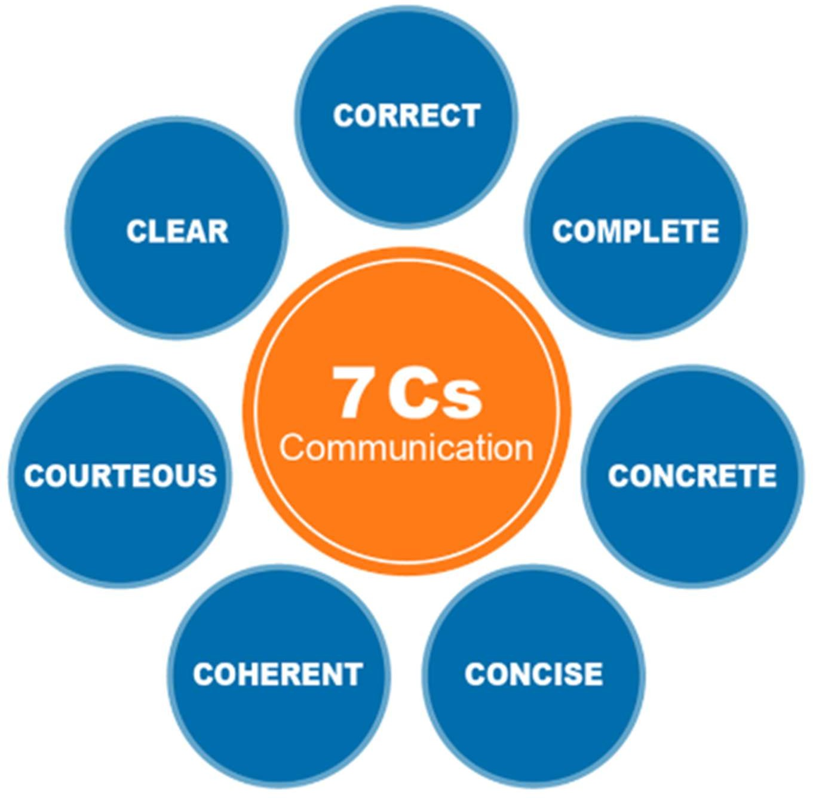

## Importance of Good Communication

Good communication is the foundation of any successful relationship, be it professional or personal. In the workplace, it leads to better teamwork, enhanced collaboration, and increased efficiency. It enables team members to understand their responsibilities, work cohesively, and avoid unnecessary errors. It also plays a crucial role in resolving conflicts by promoting transparency and mutual understanding. Clear communication helps in setting well-defined expectations and provides constructive feedback, leading to continuous improvement.

Good communication builds trust and respect among peers, which is essential for maintaining a healthy and productive work environment. For leaders, the ability to articulate a vision, share goals, and offer guidance is indispensable in motivating and aligning the team towards common objectives. It empowers employees, fosters a sense of belonging, and drives innovation.

In academics, communication skills allow students to express their ideas, present their knowledge confidently, and engage effectively in group discussions, seminars, and projects. During interviews, strong communication can leave a lasting impression, showcasing not just subject knowledge but also interpersonal competence.

In daily life, communication prevents misunderstandings, nurtures relationships, and reinforces emotional connections with family and friends. It helps individuals articulate their feelings, needs, and aspirations clearly, making everyday interactions more meaningful.

Therefore, honing communication skills contributes significantly to an individual's personal growth and professional success. It is a lifelong skill that continually evolves and becomes more refined with practice, feedback, and experience.

## Video Resume

A video resume is a modern, creative way for job seekers to present their qualifications, skills, experiences, and personality to potential employers using a short, recorded video format. Unlike a traditional paper or digital resume that only lists accomplishments and career highlights in a text-based format, a video resume provides a visual and auditory representation of a candidate, allowing them to make a more personal and memorable impression.

Typically lasting between 60 to 120 seconds, a well-structured video resume includes:

* A brief self-introduction, mentioning the candidate's name, educational background, and career aspirations.
* A summary of key skills, certifications, technical competencies, and relevant experience.
* Specific achievements, projects, or internships that highlight the applicant's suitability for the targeted role.
* A brief explanation of why the candidate is an ideal fit for the company or position.
* A closing statement expressing gratitude and enthusiasm for potential opportunities.

Creating a video resume allows applicants to showcase their communication skills, confidence, personality, and professional demeanour, which are often difficult to convey through text alone. For roles in sectors like media, marketing, public relations, design, customer service, and entertainment, where presentation and creativity are crucial, video resumes can serve as a powerful first impression.

Additionally, video resumes demonstrate a candidate’s technological proficiency and comfort with modern tools and trends—an important attribute in today’s digitally-driven job market. They offer employers a quick preview of how a candidate might interact in team meetings, client presentations, or public speaking scenarios.

However, to be effective, a video resume should maintain a professional tone, appropriate attire, and good video quality (lighting, audio, and background). The content should be concise, focused, and tailored to the job role. Overly long or poorly edited videos may have a negative impact.

As employers increasingly value soft skills and cultural fit, video resumes bridge the gap between qualifications and personality. They are especially useful for freshers or entry-level professionals looking to differentiate themselves in a crowded market and highlight their enthusiasm, energy, and potential.

In conclusion, a video resume is not just a supplement to a traditional resume— it's a strategic tool that, when done right, can give applicants a competitive edge in the hiring process.

## Teamwork Skills Everyone Should Have

Teamwork is the ability to work well with others to achieve a common goal. It is essential in both academic settings and professional environments. Strong teamwork promotes collaboration, mutual respect, and effective problem-solving. To be a valuable team player, one must develop a set of key skills that enhance team performance.

Communication is the cornerstone of teamwork. Team members must express their ideas clearly, listen actively, and provide constructive feedback. Collaboration involves working together, sharing responsibilities, and supporting each other to reach a shared objective. Accountability means taking ownership of one’s tasks and being dependable so that others can rely on you.

Adaptability is important because team roles and plans can often change. Being flexible and open to new ideas helps the team adjust smoothly. Problem-solving skills enable members to tackle challenges and come up with creative solutions as a group. Respect ensures that every member’s idea and contribution are valued, creating a positive environment.

Time management helps the team stay organized and meet deadlines. Conflict resolution is also crucial, as disagreements are natural in any group. The ability to resolve issues calmly and respectfully helps maintain harmony. Altogether, these teamwork skills lead to efficient cooperation, better outcomes, and shared success.

## Thinking -Strategic Thinking, Critical Thinking, Lateral Thinking

Thinking skills are essential for effective decision-making, problem-solving, and personal growth. Among the most important thinking styles are strategic thinking, critical thinking, and lateral thinking, each serving a unique purpose in both academic and professional life.

Strategic thinking is the ability to plan for the future by setting long-term goals and determining the best paths to achieve them. It involves analysing situations, anticipating challenges, and aligning actions with a bigger vision. Strategic thinkers often focus on long-term impact, resource planning, and goal alignment.

Critical thinking involves objectively analysing facts and information to form reasoned judgments. It includes evaluating evidence, identifying assumptions, detecting inconsistencies, and drawing logical conclusions. This skill is vital for academic work, business decisions, and solving complex problems.

Lateral thinking, on the other hand, is about approaching problems in creative and unconventional ways. It encourages looking at situations from different angles, thinking “outside the box,” and breaking away from traditional patterns of thought. Lateral thinkers are often innovative and resourceful.

Together, these thinking styles enhance an individual’s ability to make sound decisions, solve problems effectively, and innovate. They are essential in today’s dynamic world, where challenges require a mix of planning, analysis, and creativity. Developing these thinking skills prepares individuals to navigate uncertainty and lead with clarity and purpose.

## Change Management –VUCA

Change management is the structured approach of helping individuals, teams, and organizations transition from a current state to a desired future state. It involves preparing, supporting, and guiding people through change to ensure successful outcomes. In today's rapidly evolving environment, effective change management is more important than ever.

A key concept in understanding modern challenges is VUCA, which stands for Volatility, Uncertainty, Complexity, and Ambiguity. This framework describes the unpredictable and fast-changing nature of the world today, especially in technology, business, and global affairs.

* Volatility refers to the speed and turbulence of change. Markets, technologies, and trends shift rapidly, requiring agility and quick responses.
* Uncertainty means outcomes are unpredictable, and past experiences may not always guide future decisions. This calls for flexibility and openness to change.
* Complexity involves multiple interconnected factors that influence decisions, such as global supply chains or digital ecosystems. Understanding these requires analytical thinking.
* Ambiguity refers to a lack of clarity and the difficulty in interpreting situations where information is incomplete or conflicting.

In such a world, successful change management requires clear communication, strong leadership, and continuous learning. Leaders must be able to anticipate change, build resilient teams, and foster a culture of innovation. Employees must be adaptable, open-minded, and willing to reskill or upskill.

Organizations that embrace the VUCA model in their change management strategies are better equipped to navigate challenges, seize opportunities, and sustain growth. Thus, understanding VUCA and implementing effective change management practices are critical for long-term success in any field.

# SWOT- JOHARI

The combination of SWOT analysis and the JOHARI Window creates a powerful self-assessment tool that enhances personal and professional development. While both models are effective on their own, integrating them provides deeper insights into self-awareness, communication, and growth potential.

* SWOT stands for Strengths, Weaknesses, Opportunities, and Threats. It helps individuals and organizations evaluate internal capabilities and external challenges. This analysis supports decision-making, goal setting, and strategic planning by identifying areas to leverage and improve.
* The JOHARI Window, developed by Joseph Luft and Harrington Ingham, is a model for self-awareness, interpersonal relationships, and feedback. It includes four quadrants:
  1. Open Area – Known to self and others.
  2. Blind Area – Unknown to self but known to others.
  3. Hidden Area – Known to self but hidden from others.
  4. Unknown Area – Unknown to both self and others. By combining SWOT with the JOHARI Window:
* One can map Strengths in the Open and Hidden areas to build confidence and visibility.
* Weaknesses in the Blind or Hidden areas can be reduced through feedback and self-reflection.
* Opportunities often lie in the Unknown area, waiting to be discovered through exploration and experience.
* Threats may stem from unacknowledged weaknesses or external pressures, highlighting the need for greater awareness.

Using this dual approach encourages continuous personal growth, better communication, and improved relationships. It also helps individuals understand

how they are perceived by others and what they can do to align their self-image with reality.

In professional settings, this method fosters stronger teamwork, leadership, and performance by encouraging feedback, reducing misunderstandings, and increasing mutual trust. Overall, the SWOT–JOHARI combination is a valuable strategy for enhancing emotional intelligence and achieving well-rounded development.

## SWOT – Role Model

Conducting a SWOT analysis based on a role model is a powerful technique for learning from someone you admire and applying those insights to your own personal and professional development. A role model serves as an inspiration— someone whose actions, achievements, mindset, and values you wish to emulate. By evaluating their strengths, weaknesses, opportunities, and threats, you gain a structured perspective on what contributes to their success and how you can chart a similar path.

* Strengths: Identify the qualities, skills, and habits that make your role model successful. These may include leadership abilities, decision-making skills, emotional intelligence, or dedication to continuous learning. Observing these traits allows you to adopt and develop them in your own life.
* Weaknesses: Acknowledging that even the most successful individuals have limitations helps create a realistic view of growth. Understanding how your role model navigates their weaknesses can teach you how to manage yours with resilience and strategy.
* Opportunities: Learn how your role model leverages opportunities—be it networking, education, innovation, or adaptability. These insights can guide you in recognizing and seizing opportunities in your own journey.
* Threats: Assessing the external challenges your role model faces—like competition, societal pressures, or time constraints—helps you prepare for similar threats in your environment.

This method encourages self-reflection and goal alignment. For example, if your role model is an entrepreneur known for innovation and ethical business practices, you can evaluate which of those traits you currently possess, which ones you need to develop, and what steps you must take to bridge the gap.

## Reason for Fitting in Dream Company

Joining my dream company aligns perfectly with both my professional aspirations and personal values. I believe I am an ideal fit because I bring a unique blend of skills, passion, and a growth-oriented mindset that matches the organization's vision and culture.

My strong communication skills, both verbal and written, enable me to interact effectively with diverse teams and stakeholders, contributing to smooth collaboration and understanding. I possess a positive attitude and am highly adaptable, which allows me to thrive in dynamic environments and handle challenges efficiently.

Having worked on real-world projects and internships, I’ve developed practical knowledge and hands-on experience that complement my academic foundation. I understand the importance of teamwork, punctuality, and accountability, and I always strive to deliver my best work with integrity and professionalism.

My problem-solving abilities, supported by critical and strategic thinking, enable me to approach situations analytically and find innovative solutions. I constantly seek self-improvement and stay updated with the latest trends and technologies relevant to the industry.

Most importantly, I share the company’s commitment to excellence, innovation, and ethical practices. I am passionate about contributing to meaningful projects and working in an environment that encourages creativity and continuous learning. I view this opportunity not just as a job but as a platform to grow, contribute, and make a lasting impact.

In essence, my values, capabilities, and enthusiasm perfectly align with what the company stands for, making me a confident and motivated candidate ready to take on responsibilities and contribute positively to the team.